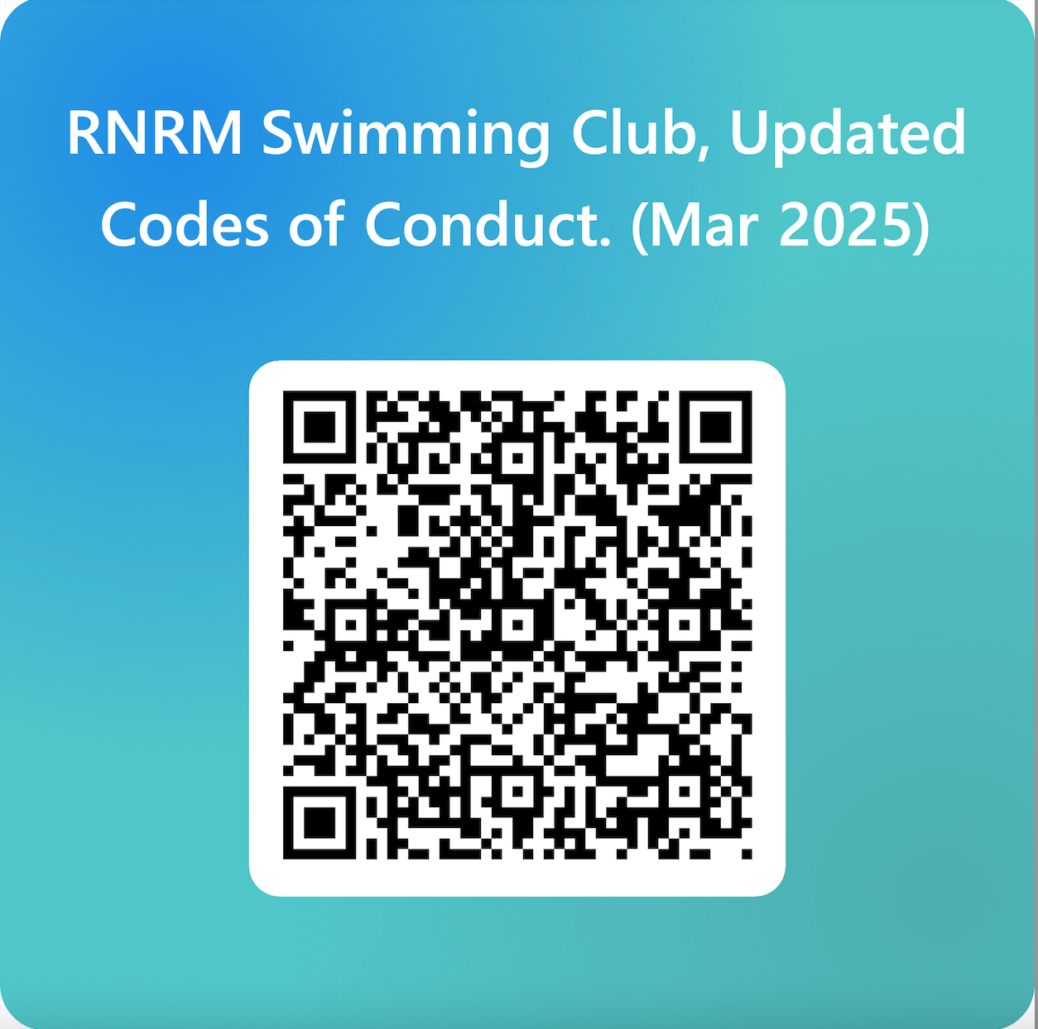

You have all signed to say you have read the current (2023) Club and Swim England Codes of Conduct, however, these have now been reviewed and uploaded here.
Please read and discuss with U18 Swimmers and complete this Confirmation Form (or QR Code above) to say you have read, discussed and agree.

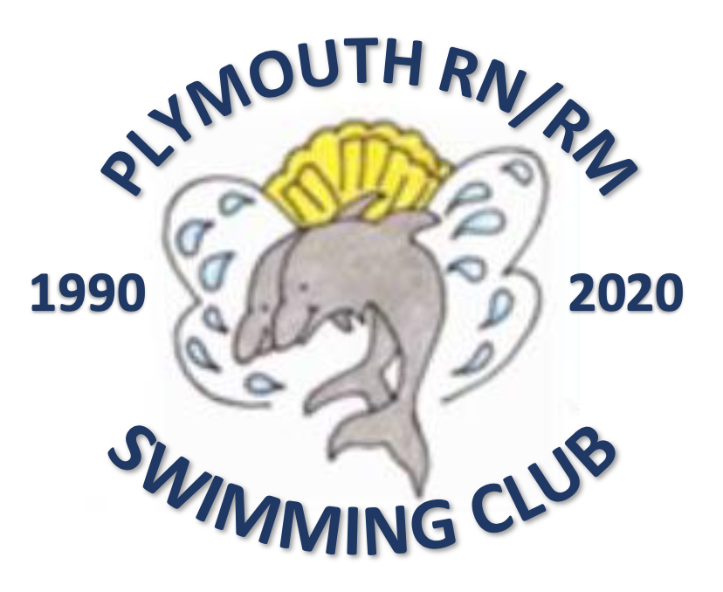
Code of Conduct

Parents/guardians

As a registered Swim England Member, and parent/guardian of a Member (under 18 years of age) at the Club, or a parent/guardian of a Club Member (under 18 years of age) but not a registered Swim England Member yourself, you are required to agree to this code of conduct.

As a parent/guardian you have the right to:

- Be assured that your child is safeguarded at all times during activity with the club.

- Know who the Welfare Officer(s) is/are and how to contact them.

  - rnrmswimmingwelfare@yahoo.com (David Boote)

- Be informed of Wavepower and appropriate safeguarding and welfare reporting procedures.

- Know that any concerns about your child’s welfare will be listened and responded to.

- Know that anyone training or looking after your child at a club activity has the appropriate qualifications, checks and training.

- Be informed of any problems or concerns relating to your child raised by their coach.

- Know how to access the club policies, rules and procedures including the club complaints process and who to contact.

- Provide your consent or otherwise for photography and trips away.

As a parent/guardian of a Club Member (under 18 years of age) we expect you to:

- Make sure your child has the right kit for training and competitions.

- Ensure your child arrives to sessions on time and is picked up promptly.

- Let the club know if you’re running late to collect your child, if your child is going home with someone else or you have made alternative arrangements.

- Complete all consent, contact and medical forms and update us straight away if anything changes.

- Respect the decisions made by your child’s coach or teacher but understand you have the right to raise any concerns regarding your child. We will arrange a mutually convenient time so you can talk to us.

- Remember that children get a wide range of benefits from participating in one of our sports, including making friends, having regular exercise and developing new skills. It’s not all about winning.

- Not enter poolside or interrupt training or competitions unless in an emergency situation.

- Talk to your child and ensure they understand the rules of the club and the sport.

- Ensure your child understands the Athlete Code of Conduct.

We expect certain standards of behaviour from all club members as well as parents/guardians/grandparents.

By agreeing to this Code of Conduct you agree to:

- Behave positively as a spectator at training or competitions and treat others with respect.

- Give encouragement to your child well and provide support when they are struggling.

- Respect and celebrate differences in the club and not discriminate against anyone else on the grounds of gender, race, sexual orientation, faith, ability, or any other relevant characteristic.

- Respect anyone competing for other teams at competitions.

- Respect all volunteers, committee members, coaches and teachers at the club.

- Understand that the use of abusive or inappropriate language, bullying, physical violence or any other behaviour which hurts others will not be tolerated at the club.

- Report any incidents of abuse, bullying or other unacceptable behaviour to the Welfare Officer, even if you’re just a witness.

Breaches of this Code of Conduct will result in disciplinary action being taken against you by the club committee and any behaviour which may be a criminal offence will be reported to
Police and any other relevant authority, by the club.

Continued breaches of this code of conduct by a parent/guardian (whether a member or not) may require the club to stop your child’s continued participation in club activity

Code of Conduct
Athletes (under 18)

This code is something that you as an athlete should refer to in relation to your rights as an athlete, the respect you should expect but also that which you demonstrate to other members, what is expected of you in terms of listening and being listened to and your behaviour as a member of the club.

As a member of our club, you have the right to:

- Feel safe and know how you can raise concerns.

- Be listened to.

  - rnrmswimmingwelfare@yahoo.com (David Boote)

- Be involved and contribute towards decisions within the club or activity.

- Be respected and treated fairly by every member of the club.

- Feel welcomed, valued and not judged based on your race, gender, sexuality, faith, ability or any other relevant characteristic.

- Be encouraged and developed with our help and support.

- Be looked after if there’s an accident or injury and have your parents/guardians/ emergency contact informed, where appropriate.

As a member of our club we expect you to:

- Be aware of Wavepower and adhere to relevant guidance.

- Adhere to the Swim England regulations, Code of Ethics, Club Constitution and rules.

- Listen to your coach or teacher, behave responsibly and speak out when something isn’t right.

- Never leave the premises (at either training or a competition) without agreeing it with your coach, teacher or team manager first. This is just as important for our adult members as well as those under 18.

- Make it to training and competitions on time and if you’re running late, let a member of the club know.

- Make your coach or teacher aware if you have any difficulties attending training or competitions.

- Bring the right kit to training and competitions.

- Take care of equipment and premises as if they were your own.

- Support and encourage your team mates.

- Respect volunteers and competitors at competitions.

- Respect the committee members, coaching and teaching team and volunteer helpers at all times.

- Get involved in club decisions, it’s your sport too.

We expect certain standards of behaviour from our members. By becoming a member of the club and therefore agreeing to this Code of Conduct you agree to:

- Follow the rules of the club, squad or activity at all times.

- Respect and celebrate differences in the club and you will not discriminate against anyone else on the grounds of age, gender, race, sexual orientation, faith, ability, or any other relevant characteristic.

- Understand that the use of abusive or inappropriate language, bullying, physical violence or any other behaviour which hurts others will not be tolerated by the club.

- Respect the privacy of others especially in the changing rooms.

- Not use any mobile device, at any time, in the changing areas.

- Report any concerns you have about someone taking photographs or footage of others in the changing areas.

- Report any incidents of abuse, bullying or other unacceptable behaviour to the Welfare Officer, even if you’re just a witness.

Breaches of this Code of Conduct will result in disciplinary action being taken against you by the club committee and any behaviour which may be a criminal offence will be reported to Police and any other relevant authority, by the club.

Code of Conduct
Athletes (18 and over)

This code is something that you as an athlete should refer to in relation to your rights as an athlete, the respect you should expect but also that which you demonstrate to other members, what is expected of you in terms of listening and being listened to and your behaviour as a member of the club.

As a member of our club, you have the right to:

- Feel safe and know how you can raise concerns.

- Be listened to.
  - rnrmswimmingwelfare@yahoo.com (David Boote)

- Be involved and contribute towards decisions within the club or activity.

- Be respected and treated fairly by every member of the club.

- Feel welcomed, valued and not judged based on your race, gender, sexuality, faith, ability, or any other relevant characteristic.

- Be encouraged and developed with our help and support.

- Be looked after if there’s an accident or injury and have your emergency contact / next of kin informed, where appropriate.

As a member of our club we expect you to:

- Be aware of Wavepower and adhere to relevant guidance.

- Adhere to the Swim England regulations, Code of Ethics, Club Constitution and rules.

- Respect your coach or teacher, behave responsibly and speak out when something isn’t right.

- Let someone know if you are leaving the premises (at either training or a competition). This is just as important for our adult members as well as those under 18 to know that you are safe at all times.

- Let someone know if you’re running late, particularly at a competition where it may impact on other members.

- Let someone know if you have any difficulties attending training or competitions.

- Support and encourage your team mates.

- Respect volunteers and competitors at competitions.

- Respect the committee members, coaching and teaching team and volunteer helpers at all times.

- Get involved in club decisions, it’s your sport too.
We expect certain standards of behaviour from our members. By becoming a member of the club and therefore agreeing to this Code of Conduct you agree to:

- Follow the rules of the club, squad or activity at all times.

- Respect and celebrate differences in the club and you will not discriminate against anyone else on the grounds of age, gender, race, sexual orientation, faith, ability, or any other relevant characteristic.

- Understand that the use of abusive or inappropriate language, bullying, physical violence or any other behaviour will not be tolerated by the club.

- Respect the privacy of others especially in the changing rooms.

- Not use any mobile device, at any time, in the changing areas.

- Report any concerns you have about someone taking photographs or footage of others in the changing areas.

- Report any incidents of abuse, bullying or other unacceptable behaviour to the Welfare Officer, even if you’re just a witness.

Breaches of this Code of Conduct will result in disciplinary action being taken against you by the club committee and any behaviour which may be a criminal offence will be reported to
Police and any other relevant authority, by the club.

Code of Conduct
Committee members, officials and volunteers

As a volunteer at the club, we understand you have the right to:

- Be supported in your role and respected and treated fairly by the club.

- Know who the Welfare Officer(s) is/are and how to contact them;

  - rnrmswimmingwelfare@yahoo.com (David Boote)

- Be informed of Wavepower and appropriate reporting procedures.

- Be informed of the club complaints process and who to contact at the club.

- Be aware of the club rules and procedures.

- Be involved and contribute towards decisions within the club.

- Feel welcomed, valued and listened to.

As a volunteer of the club we expect certain standards of behaviour from our members. By becoming a member of the club and therefore agreeing to this Code of Conduct you agree to:

Rules and Regulations | Volunteering and Behaviour | You the person
Adhere to and implement Wavepower. | Refer all safeguarding and welfare concerns to the Welfare Officer. | Champion everyone’s right to take part and celebrate difference in our club or activity by not discriminating against anyone else on the grounds of gender, race, sexual orientation, faith, ability, or any other relevant characteristic.
Adhere to the Swim England Equality and Diversity Policy. | Respect children’s trust and rights whilst being honest and open with them. | Challenge and address instances of poor, negative, aggressive or bullying behaviour amongst children. Seek advice from the Welfare Officer where necessary.
Adhere to the Swim England regulations, Code of Ethics, Club Constitution and rules. | Treat all personal information about members or their families on a confidential ‘need-to-know’ basis unless information sharing with others is required to protect and safeguard a child from harm. | Keep any qualifications and CPD up to date relevant to your role.

Rules and Regulations | Volunteering and Behaviour | You the person
Adhere to any conditions stipulated under the pool hire agreement. | Encourage children to behave in a positive manner and follow the rules of the club and sport. | Complete Swim England safeguarding training every three years as applicable to your role.
Keep children safe in sessions and at competitions with appropriate staffing ratios. | Adhere to your role responsibilities allowing others to adhere to theirs. | Ensure you have a current Disclosure and Barring Service (DBS) check (renewable every three years) as applicable to your role.
Ensure any equipment used is fit for purpose, safe to use and accessible. | Promote a positive and welcoming environment and culture within the club.
Follow the club procedures should a child have an accident or suffer an injury. | Always put the wellbeing, health and safety of the child before all other considerations including the development of performance.
Ensure any complaints raised to you are appropriately referred under the Swim England Club Complaints process.
Support the club as required in completing and maintaining minimum affiliation standards.

Breaches of the Code of Conduct will result in disciplinary action being taken against you by the club committee under the judicial regulations. Continued issues and repeated breaches may result in your dismissal from the club. Any criminal offence will be reported to Police and any other relevant authority, by the club.

Code of Conduct
Coaches and teachers

This code is something that you as a member of the coaching or teaching team should refer to in relation to your rights in your role, the respect you should expect but also that which you demonstrate to all members, what is expected of you in terms of listening and being listened to and your behaviour as a member of the club.

As a coach or teacher, you have the right to:

- Be supported in your role and respected and treated fairly by the club.

- Be informed of Wavepower and appropriate reporting procedures.

- Know who the Welfare Officer(s) is/are and how to contact them.
  - rnrmswimmingwelfare@yahoo.com (David Boote)

- Be informed of the club complaints process and who to contact at the club.

- Be aware of the club rules and procedures.

- Be involved and contribute towards decisions within the club.

- Have access to ongoing training and CPD in all aspects of your role.

As a coach or teacher of the club we expect certain standards of behaviour from our members. By becoming a member of the Organisation and therefore agreeing to this Code of Conduct you agree to:

Rules and Regulations | Coaching and Behaviour | You the person
Adhere to and implement  Wavepower. | Respect your position of trust to maintain appropriate boundaries and relationships with athletes, not using your position to obtain personal benefit or reward. | Champion everyone’s right to take part and celebrate difference in our club or activity by not discriminating against anyone else on the grounds of gender, race, sexual orientation, faith, ability, or any other relevant characteristic.
Adhere to the Swim England Equality and Diversity Policy. | Not engage in any behaviour that constitutes any form of abuse. | Champion everyone’s right to take part and celebrate difference in our club or activity by not discriminating against anyone else on the grounds of gender, race, sexual orientation, faith, ability, or any other relevant characteristic.

Rules and Regulations | Coaching and Behaviour | You the person
Adhere to the Swim England regulations, Code of Ethics, Club Constitution and rules. | Refer all safeguarding and welfare concerns to the Welfare Officer. | Challenge and address instances of poor, negative, aggressive or bullying behaviour amongst children.  Seek advice from the Welfare Officer where necessary.
Adhere to any conditions for teaching and coaching under the pool hire agreement. | Respect children’s trust and rights whilst being honest and open with them. | Keep your coaching and/or teaching qualifications and CPD up to date.
Keep children safe in your sessions with appropriate staffing ratios, using safe methods of instruction and techniques and by putting their safety first. | Lead by example creating and promoting positive behaviour and a safe culture. | Complete Swim England safeguarding training every three years.
Ensure any equipment used is fit for purpose, safe to use and accessible. | Encourage children to behave in a positive manner and follow the rules of the club and sport. | Ensure you have a current Disclosure and Barring Service (DBS) certificate (renewable every three years).
Follow the club procedures should a child have an accident or suffer an injury. | Ensure team/squad selection is clear and transparent and be fair and equal when making decisions.
 | Use positive and constructive methods when teaching and coaching and ensure programmes are appropriate for the age, ability and experience of the child.
 | Always put the wellbeing, health and safety of the child before all other considerations including the development of performance.

Breaches of the Code of Conduct will result in disciplinary action being taken against you by the club committee under the judicial regulations or if you are employed under your contract of employment. Continued issues and repeated breaches may result in your dismissal from the club. Any criminal offence will be reported to Police and any other relevant authority, by the club.

